Pulse 2x1100 Mods.

Modification document for the Pulse models

ZC-P2X1100

ZC-P2X1100-1

The following is a modification procedure for the Pulse 2x1100 amplifier. Please read through this document carefully before proceeding with any modifications. If you have any questions, please do not hesitate to contact the C-Audio Service Department.

WARNING

All work must be carried out by a qualified electronics engineer.

This unit utilises Switch Mode Power Supply technology (SMPSU). The Live and Neutral from the mains supply are Rectified and smoothed directly, this results in about 320Vdc between ‘LIVE GND’ and +HT. ‘LIVE GND’ is named as such because it is not isolated from mains, but it is the reference point for the PSU. If you need to stick a scope probe around the primary side with the unit plugged in you must connect mains via an Isolation Transformer. Without this, at best you will only trip your RCD breaker, at worst you or your scope may not live to regret it. Do not forget that 320Vdc is still pretty shocking whether it is isolated or not. It is recommended that the unit be disconnected from the mains supply for at least 1 hour before removing the cover to allow parts of the power supply to discharge.

You will need to remove the PCB from the chassis in order to perform the modifications; this is achieved by removing the following fixings. Be careful to retain all the fixings.

From the topside

- 14 x lid screws from top cover.

- 14 x rear panel screws.
- 4 x internal screws.
- 1 x nut and shake-proof washer for earthing wire on IEC connector.

From the underside

- 4 x heatsink to chassis screws.

- 3 x chassis to front panel screws.
- 1 x grounding bolt (nut accessed from inside amplifier).

With the PCB separated from the chassis it is recommended that the PSU stage be further discharged to reduce the risk of damage to components or PCB traces. This can be achieved by placing a 1k /1W resistor across the legs of C75 for 2 minutes, this will be enough time to replace the clips on the driver transistors and to check the other clips.

1

Pulse 2x1100 Mods.

This procedure is to be carried out on ALL Pulse P1100 units.

Please read the warning notice before removing any covers.

Modification 1

- Remove the heatsink clips from the output driver transistors TR57, TR15, TR13 & TR56.

- Check the insulating material used with these transistors for damage & replace if necessary.

- Refit the heatsink clips back onto the output driver transistors.

Modification 2

- Without removing them, check all the other heatsink clips for tightness, device & insulating material alignment. Replace any loose clips or damaged material. Refit any misaligned devices.

Please Note:

It is important to ensure that these devices are securely fitted, flush to the heatsink, without any air gaps if they are in any way loose, they will eventually fail

Modification 3

- Unsolder, remove and discard the following parts from the PCB. (Refer to drawing of PCB underside).

  - D13, D17, D30, D35, TR24, TR29, TR40-TR43, ZD8 & ZD9, R46, R75, R109, R138, R160, R162, R194, R232 & R250 & TX4 (Retain fixings for TR24 & TR29).
  - Unsolder & remove C74, C75 & C82 as one item. Once they are free from the PCB, break away the glue. Keep these parts as they will need to be re-fitted, they are removed to gain access to other components.

  - Lift the Cathode (Bar end) of D29 and Anode of D31 from the PCB, clear the holes of solder.

  - Fit the 47uH inductor (item 3) as shown in attached drawing (Drawing 2).
  - Refit C74, C75 & C82 then apply hot melt glue to C74, C75 & C82 and to the 47uH inductor (item 3).

  - Fit 10Ω 1 Watt resistor (Item 1) to position R160.
  - Fit 100Ω resistor (Item 5) to position R109 & R138.
  - Fit 56Ω resistor (Item 7) to position R232 & R250.
  - Fit 47K 1 Watt resistor (Item 6) to position R46, R75, R162 & R194.
  - Fit 24V/500mW Zener diode (item 2) to positions ZD8, & ZD9 (Observe polarity).
  - Fit ZTX651 X 2 (item 8) to positions TR40 & TR42 (Observe polarity).
  - Fit ZTX751 X 2 (item 9) to positions TR41 & TR43 (Observe polarity).

  - Fit G50N60 IGBT’s (item 4) to positions TR24 & TR29 (Don’t forget to smear the metal backs of the IGBT’s with heatsink compound BEFORE re-fitting against the insulated material & fixing them back to the Pulse heatsink).
  - Replace fuse F2 (Rear panel) with T10A (item 10).
  - Fit 4 X 4700pF 63 volts capacitors to channel A driver circuit (item 11 & observe correct mounting / fitting. See pictures on last two sheets).
  - Fit 4 X 4700pF 63 volts capacitors to channel B driver circuit (item 11 & observe correct mounting / fitting. See pictures on last two sheets).
  - Fit the updated Pulse Toroid transformer TX4 (item 12). Observe polarity of the white mark on one side of the base of the transformer & align with white square on Pulse PCB board.

2

Pulse 2x1100 Mods.

Items Supplied in Modification Kit.

Item # | Description | Qty | Order Number
1 | 10Ω 1 Watt Resistor | 1 | AE0100
2 | 24V / 500mW Zener Diode | 2 | BD10022
3 | 47uH Inductor | 1 | HC10012
4 | G50N60 IGBT | 2 | BD10032
5 | 100Ω Resistor | 2 | M100R
6 | 47K 1 Watt Resistor | 4 | AE047
7 | 56Ω Resistor | 2 | M56R
8 | ZTX651 Transistor | 2 | MC651
9 | ZTX751 Transistor | 2 | MC751
10 | T10A fuse | 1 | ZD10016
11 | 4700pF 63 Volts Square Capacitor | 8 | CTRC470063SWH
12 | Updated Pulse Toroid Transformer | 1 | CTRVTT2564SWH

Testing of modified unit:

Once the unit has been modified and replaced into the chassis, you should carry out the following test to ensure reliability.

- Input a 1 kHz Sinewave signal into channel 1 at 5dBu.

- Connect a dummy load rated at 4Ω.

- Turn level control to maximum for 30 seconds.

- Place a dead short across output for a further 30 seconds.
- Remove the short and check output recovers.
- Reduce input level to 1dBu and check for clean sinewave.
- Repeat above for other channel.

3

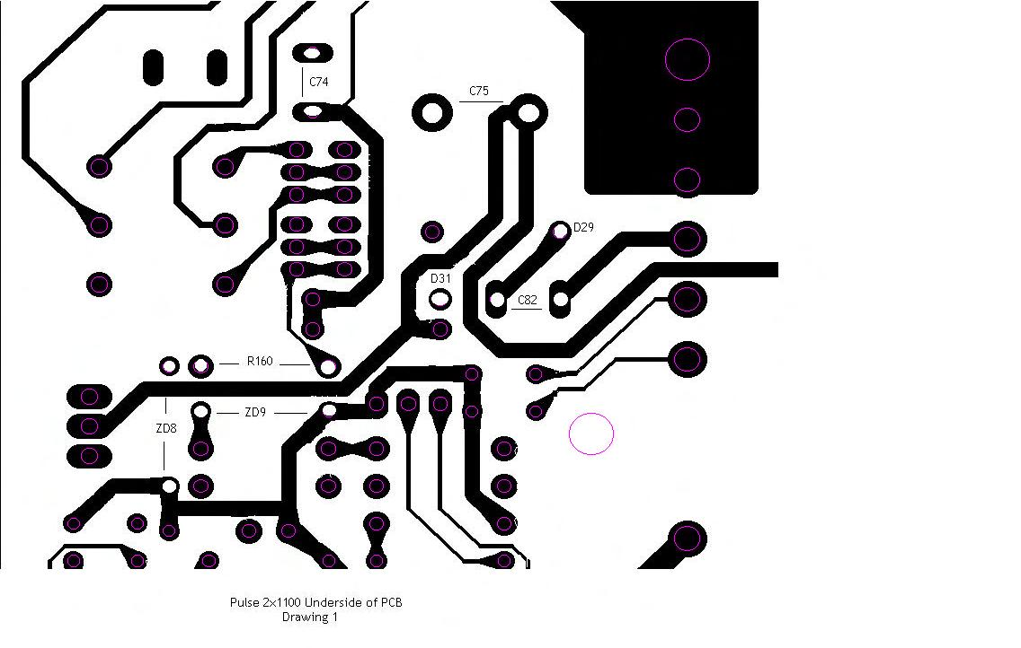

Pulse 2x1100 Mods.

Pulse 2x1100 Drawing 2

Before:--
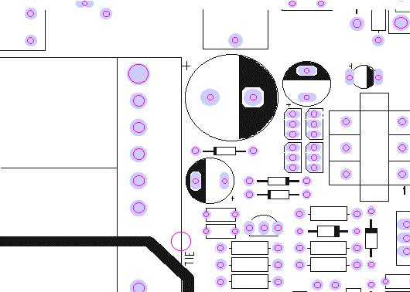

After:--
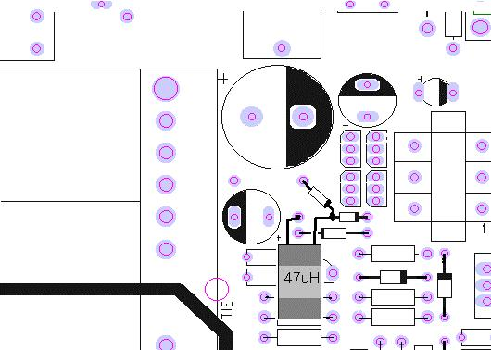

Fitment of capacitors for Pulse 2x1100 on channel A
(Item 11).

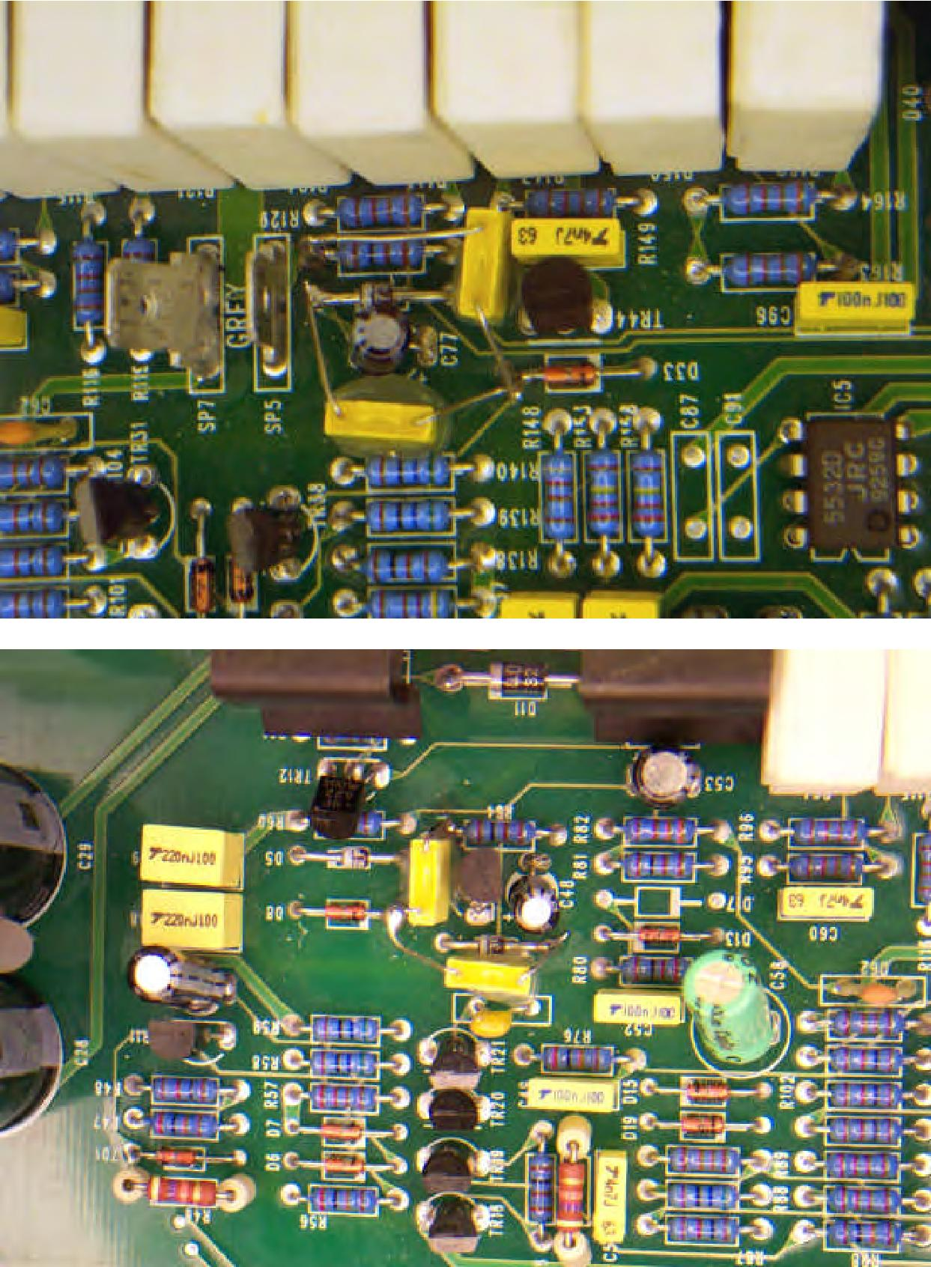

Fitment of capacitors for Pulse 2x1100 on channel B
(Item 11).

